Emergency Reporting System

Android

System Manual

##### Client – Amanda Cullin

##### Project Advisor – Dr. Zhengrui Qin

##### Project Team – The Elite Code smiths

##### Date: April 16, 2017

##### Version: 1.0

# About this Document -System Manual

This document contains the basic information for the Emergency Reporting system administration from implementation to operations. It is intended as a minimal guide for the project and the depth of system documentation that should be transitioned to operations.

About this Document - System Administration Manual 2

Revision History 5

1. Introduction 6

1.1 Introduction and Purpose 6

1.2 Project References 6

2. SYSTEM OVERVIEW 6

2.1 System Application 6

2.2 Information Inventory 6

2.2.1 Resource Inventory 6

2.3 Processing Overview 6

2.4 Communications Overview 7

2.5 Security 7

3. SYSTEMS ADMINISTRATION 7

3.1 User and Group Accounts 7

3.1.1 Adding/Deleting Users 8

3.1.2 Setting User Roles/Responsibilities 8

3.2 Security Procedures 8

3.2.1 Issuing IDs and Passwords 8

3.2.2 License Agreements 8

3.3 Network Maintenance 8

3.3.1 Communications Equipment 8

3.4 Inventory Management 8

3.4.1 Maintaining Hardware and Software Configurations 8

3.4.2 Installing Software/Hardware (New, Upgrades) 9

3.5 End-User Support - Procedures for Support and Contract Information 9

3.6 Documentation 9

3.6.1 Troubleshooting Issues 9

3.7 Database Maintenance 9

3.7.1 Database User/Group Access 9

3.7.2 Adding/Deleting Users to Database 9

3.7.3 Setting User Permissions for Database 9

3.7.4 Re-indexing Database 9

3.7.5 Packing/Compressing Database 9

3.7.6 Data Entry/Modification/ Deletion 9

3.7.7 Database Backup and Restore 10

3.8 Application Maintenance 10

3.8.1 Application User/Group Access 10

3.8.2 Adding/Deleting Application users 10

3.8.3 Setting User Application Permissions 10

3.8.4 Procedures to Start and Stop the Application 10

3.8.5 Application Flow Chart 11

3.8.6 Description of Major Program or Sub-program Modules 11

# Revision History

|  |  |  |
| --- | --- | --- |
| Revision Number | Date | Comment |
| 1.0 | April 16, 2017 | System Manual |
|  |  |  |
|  |  |  |
|  |  |  |

# 1. Introduction

*This section provides general idea about the system from initial point to the exit point. This acts as guideline for every user on how to utilize the system. First install the application from Appstore and the mobile must have internet connection for the smooth running of the application.*

## 1.1 Introduction and Purpose

Emergency Reporting System is an Android application, restricted for Northwest Missouri state university students. This application is developed to help students in reporting emergencies such as Health, Fire, Harassments, etc., to UPD (University Police Department).

## 1.2 Project References

This project is developed by studying present emergency reporting applications in Appstore. Android application development is studied from different websites like www.vogella.com, www.tutorialspoint.com/android, http://developers.android.com.

# 2. SYSTEM OVERVIEW

## 2.1 System Application

An android mobile application which helps people in their emergency situations like reporting a threat to police in hostile situations with just touch of a button, seeking immediate health assistance, seeking fire department assistant or also to report any suspicions activities around them. Here the users whoever is using this application becomes our intended audience. If a person is in hostile situation like, if that person is being followed by some unknown or suspicious person then they can open this application and with just touch on the button which is on the screen sends a message to police station with the persons location requesting for help and the police can take immediate actions to see through that the person is okay. In this way this application is helpful to so many people and also the police department can prevent or save so many people from so many dangers.

## 2.2 Information Inventory

All the data that is produced by the app such as user’s information and the alerts that are generated are stored in the back4app database. The logic and code used for the app development is stored in GitHub. The documents and other manuals are stored in drive for backup.

### 2.2.1 Resource Inventory

The application uses back4app database to store the user’s data.

## 2.3 Processing Overview

Landing page is the first page which appears when the user opens the application and start executing. Landing page for the first time consists of screen asking for email address and password which are obtained for the user when they register. Landing page when the user opens this application for second time is the Home page which means the user need not login every time when he/she uses the application.

The user need to login to the application for the first time using his/her own credentials such as email address/Username in the username field and password usually in alphanumeric form (containing numbers, special symbols, uppercase and lower case letters). After entering correct details click on LogIn button.

Click on SignUp button in Logging On page to create new account. To create a new account fill up all the fields with your personal data and set your password and username. When you enter the details and click on Register button, all the details entered by you are saved in the database which are verified when you try to logon to the application. There is a reset button to clear all the data you entered when you wish to do so. Immediately after you click Register button you are navigated to LogIn page where you need to enter username and password and enter home page.

Whenever there is an immediate emergency for the user, then the user can just click on the icon so that an email containing user’s location and details of the user are sent to UPD staff. This is functionality is very helpful for the users in emergency situation like when they are harassed/followed by someone, kidnapped etc., where the users may not have an option to call anyone. Since the users enter their details in the application during registration that details are also sent along with location in email which is useful for UPD to contact them

Through Non-Emergency page users can report a complaint to the police department which is not emergency but the user like register a complaint to UPD. Non-emergency situations can be like complaining about stolen things, car damage, complaining about a disturbance so on. User can also upload images in pages which he/she wanted to send proof for their complaints to UPD.

User can exit from application just by closing the application. There is no logout button provided anywhere in the application because the user cannot login each time when he/she uses the application in emergency situation.

## 2.4 Communications Overview

Initially the user communicates with application for registration. The app the communicated with the database (back4Apps) and saves the user. Once the registration is done the user will now be able to send alerts to UPD using this App with a single tap on the main screen of the app.

## 2.5 Security

The main security feature that is implemented for using the app is a onetime login in one device. There is no need to login to the system every time the user want to use the app. Instead the app with save the logged in users data in the shared preference and stores the users session there by reducing the time to communicate with the app features.

# 3. SYSTEMS ADMINISTRATION

This section introduces the responsibilities of the System Administrator, as discussed in the subsequent sections.

## 3.1 User and Group Accounts

There is only one user group for this application who are the people from Northwest Missouri State University.

### 3.1.1. Adding/Deleting Users

To create a new account fill up all the fields with your personal data and set your password and username. When you enter the details and click on Register button, all the details entered by you are saved in the database which are verified when you try to logon to the application.

For deleting a user, the database administrator should do that from back4Apps.

### 3.1.2 Setting User Roles/Responsibilities

All the users created using registration process will be categorized in to the common user group who are the members of the Northwest family.

## 3.2 Security Procedures

The users email can be obtained while registration and the same email is used for later processes such as sending a link when the user forgets the password. To make sure that the password that is to be set is unbreakable, a strong password policy is set that includes a combination alphanumeric characters.

### 3.2.1 Issuing IDs and Passwords

Northwest 919 ID is used for identifying the user. The password that users create while registering an account is used for the later working of the app.

### 3.2.2 License Agreements

All the users must accept the license agreement that allow the app to use their location details and the network access permissions to send alerts.

## 3.3 Network Maintenance

Whenever there is an immediate emergency for the user, then the user can just click on the icon so that an email containing user’s location and details of the user are sent to UPD staff. Since the users enter their details in the application during registration that details are also sent along with location in email which is useful for UPD to contact them. During this process the app communicates with the available connectivity to the internet that is either Wi-Fi or the mobile network data.

### 3.3.1 Communications Equipment

Uses Wi-Fi feature that is available with the mobile phones or the data connectivity through the cellular network provider for communication with the database or to send alerts to the UPD.

## 3.4 Inventory Management

This section contains a complete hardware and software inventory to include make, model, version numbers, and serial numbers.

### 3.4.1. Software Configurations

Location services and network connectivity is required for this app to function. Minimum supported version KitKat Android 4.4.Target SDK version 24, API level 19 - Nougat.

### 3.4.2. Installing Software/Hardware (New, Upgrades)

The app can be installed from the Android App store. This can be installed using an APK file of the app. The updates of the app can be installed using the update app feature through the app store as soon as the apps updates version is published in the app store.

## 3.5 End-User Support - Procedures for Support and Contract Information

All necessary functions of Emergency Reporting System support services can be obtained, for queries and suggestions just send an email to the email addresses of the developers: kvaishureddy12@gmail.com, makkenasrinivasrao1@gmail.com, m.venkatasudheer@gmail.com, chidella1994@gmail.com, moulichowdhary@gmail.com.

## 3.6. Documentation

This section describes the documentation required of System Administrators as they perform system administration.

### 3.6.1 Troubleshooting Issues

In case of issues try to close the app and reopen. Almost all issues can be resolved by reopening the app. If the issue isn’t resolved try reinstalling the app. If the problem still persists Please write to us on any of the following emails mentioned in the End-User Support section.

## 3.7 Database Maintenance

The database maintenance is generally done by the admin and also back4app.com

### 3.7.1 Database User/Group Access

The admin with the help of back4app helps in setting the access permissions to the users.

### 3.7.2 Adding/Deleting Users to Database

The admin can Add/delete the user to the database just by deleting the user data present in the back4app.com. The process to do this is just deleting the entire row of information which contains the user’s entire information.

### 3.7.3 Setting User Permissions for Database

The user permissions to database is set by admin with the help of back4app.com

### 3.7.4 Re-indexing Database

The admin is responsible for Re-indexing the database. Re-indexing database can be done by changing the information fields while registering by the admin to the required indexes.

### 3.7.5 Packing/Compressing Database

Back4app.com is responsible for Packing/Compressing the data in the Database.

### 3.7.6 Data Entry/Modification/ Deletion

The user is responsible for the entering the user’s information while registering into the application. The information provided by the user while registering is stored in the back4app database. The admin have the controls to Entry/ Modify and delete the data in the data.

The steps required to Entry/Modify and Delete the information is just to login into the admin user account in the back4app and modify the required columns to get the required process done.

### 3.7.7 Database Backup and Restore

As the Database used here is back4app.com the data is routinely backed up, If the admin requires any data then admin can reach the back4app agents and can get the data.

3.8. Application Maintenance

3.8.1 Application User/Group Access

The application access is provided by the University Police Department as they are the admins for the application.

3.8.2 Adding/Deleting Application users

The user can add to the application as users on their own by registering in the application and the admin (UPD) can delete the users by deleting the user’s information which is stored in the back4app.

3.8.3 Setting User Application Permissions

The admin who is in this University Police Department is responsible for the permissions which are set for the application. The only permission which is set for the application is to access the user’s location. The app asks the user’s to accept the permission option the access the user’s location.

3.8.4 Procedures to Start and Stop the Application

The user has all the responsibility to start and stop the application.

**Starting the Application**:

To start the application first the user need to download and install the application then the user need to open the application and register in the application and login into the application to use the options provided in the application.

**Stopping the Application:**

To stop the application the user need to logout off the application or the user can uninstall the application.

3.8.5 Application Flow Chart

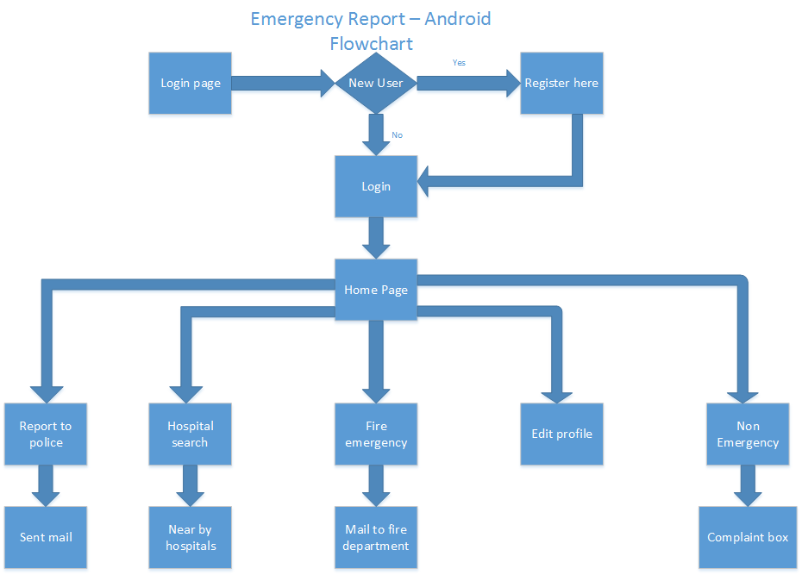

3.8.6 Description of Major Program or Sub-program Modules

There are so two different modules included in this application and they are described as below:

**New user and login Module:**

This module has sub - modules like Login, Register and forgot password.

**Login:** It requires the user to provide with the #919 id and the password for the account created to login to the users account.

**Register:** This sub-module requires the user to provide #919 id, last name, first name, E-mail id, Password and Confirm Password options. The user need to provide necessary information for all the fields to create and user account for the application. The user can click submit button to submit all the information which are provided in the fields and reset to clear the information provided. The user’s data is stored in the database, which is Back4app.

**Forgot Password:** If the user forget the password then he/she can click on forgot password option and can enter the E-mail id and click on update. A link will be sent to the user’s E-mail id and the users can reset the password using the link.

**Emergency Reporting and File a complaint:**

This module has sub – modules like Emergency button, File a complaint.

**Emergency button:** When the user is in emergency situation and requires assistance and need help from the police the user can click this button and it sends the user’s location in an E-mail to the university police department.

**File a complaint:** The user can file a complaint using this option, When the user click this option the user is directed to another page where the user can select the type of complaint from the provided options and write the complaint and click on submit. After the user click on submit the complaint is sent to university police department. Here in this page there is an emergency phone numbers option to look at the emergency contacts for the problems user may face.